Considering the operator: {'Ising1dSymmetric': {'Jz': 1.0, 'hfield': 1.0, 'pbc': 1}}

Using the sampler: {'MetropolisHastings': {'nflips': 1, 'nmoves': 200000, 'nsweeps': 10000, 'sweepfactor': 1.0, 'thermfactor': 0.1}}

Using the optimizer: {'SGD': {'learning_rate': 0.01, 'schedule_multiplier': 'fixed', 'SR': {'lambd0': 100.0, 'b': 0.9, 'lambdMin': 0.0001}, 'L2': {'L2_factor': 0.0001}}}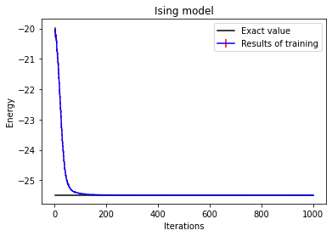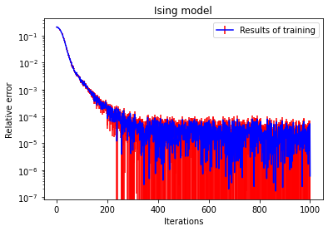

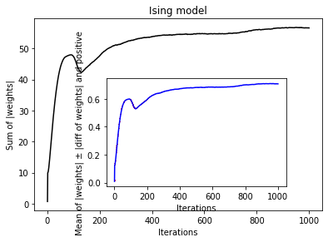

Considering the operator: {'Ising1dSymmetric': {'Jz': 1.0, 'hfield': 1.0, 'pbc': 1}}

Using the sampler: {'MetropolisHastings': {'nflips': 1, 'nmoves': 200000, 'nsweeps': 10000, 'sweepfactor': 1.0, 'thermfactor': 0.1}}

Using the optimizer: {**'Momentum'**: {'learning_rate': 0.01, 'schedule_multiplier': 'fixed', 'momentum_factor': 0.9, **'SR': False**, 'L2': {'L2_factor': 0.0001}}}

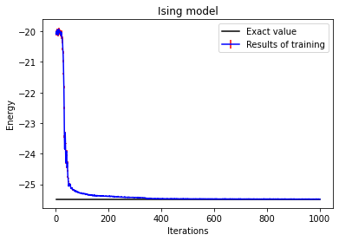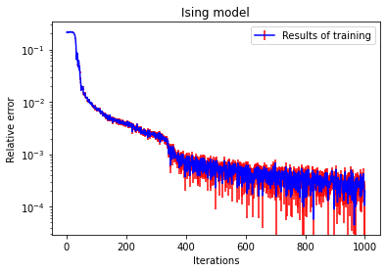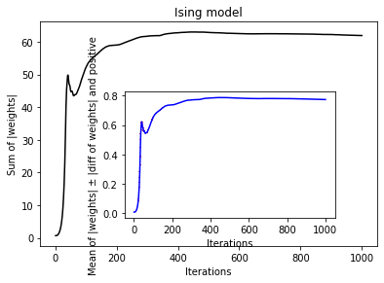

Considering the operator: {'Ising1dSymmetric': {'Jz': 1.0, 'hfield': 1.0, 'pbc': 1}}

Using the sampler: {'MetropolisHastings': {'nflips': 1, 'nmoves': 200000, 'nsweeps': 10000, 'sweepfactor': 1.0, 'thermfactor': 0.1}}

Using the optimizer: {**'Adam'**: {'learning_rate': 0.01, 'schedule_multiplier': 'fixed', 'first_momentum_factor': 0.9, 'second_momentum_factor': 0.999, 'SR': False, 'L2': {'L2_factor': 0.0001}}}

